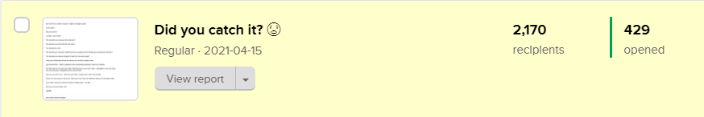
429 people opened this email: https://preview.mailerlite.com/e3o3z5

---------------------------------------------------------------

Headline: Did you catch it?
———————————————-

{&name},

Don’t tell me you didn’t because it might not happen again!

I’ll ask again!

Did you catch it?

“Lamide, Catch what?”

The moments you had your first customer?

The moment your kid took their first steps?

The moment we met?

The moments your customer said they love your product and it felt like you just had your first kiss?

The moment you made a decision to hear from me every week?

I hope you did because these are stories you can tell to inspire action.

Last week Friday - I told my students in the storywriting bootcamp “Store Your Stories”.

Any other person can start your type of business but no one and I mean - absolutely no one can have your story because it happened to you and not them.

Only you can tell it to us - and if you don’t tell it, chances are it will never be told!

There’s so many ways to store your stories but one of the most effective ways is to write about them.

If you didn’t catch any of those moments I listed earlier - too bad!

But now you know better, yes?

Lamide.

